

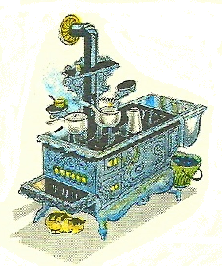Here’s what’s cookin’ **Corn Bacon Muffins**

1 cup corn flour

1 cup wheat flour

1 ½ tablespoon sugar

1 ¼ teaspoon baking soda

¼ teaspoon salt

¼ teaspoon pepper

8 strips of bacon, chopped

¼ cup vegetable (soybean) oil

1 ½ cups frozen corn

1/3 cup finely chopped onion

½ cup sour cream

1 large egg

Directions:

1. Preheat the oven to 400 degrees. Line a 12-cup muffin tin with paper baking liners. In a large bowl, whisk together the flour, sugar, baking soda, salt and pepper to combine.
2. In a large nonstick skillet, cook the bacon over medium heat, stirring occasionally, until crisp but not dry. Using a slotted spoon, transfer the bacon to a small bowl. Discard the bacon fat. Add the oil to the skillet. Add the onion and cook, stirring frequently, until softened, about 5 minutes. Stir in the chopped bacon and remove from heat.
3. Stir the corn into the dry ingredients. Make a well in the center and add the sour cream, egg and bacon mixture. Fold the ingredients together until just combined. Divide the batter equally among the baking liners. Bake, rotating the pans halfway through, until the tops are golden and a toothpick inserted in the center comes out clean, about 20 minutes. Let the muffins cool on a rack.
4. Serve with beef roast or beef chili.